Extracted Layout:

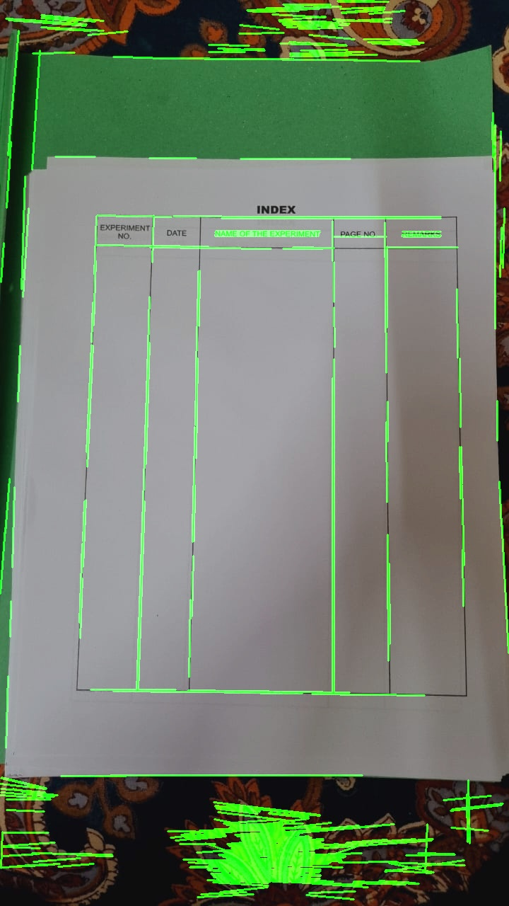

Extracted Text:

INDEX  
EXPERIMENT  
NO.  
DATE  
NAME OF THE EXPERIMENT  
PAGE NO.  
REMARKS